**Important Note**

So the bash shell (which is the default in Linux) can’t return negative values. If the return value for the program is -1, the shell returns 255. If the return value is -4, the shell returns 252. It basically adds the return value to 256 and returns that. For this part of the assignment I made it return positive numbers (1,2,3,etc). Sorry if this causes any problems.

Too few parameters:

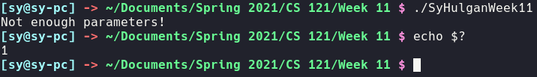

Too many parameters:

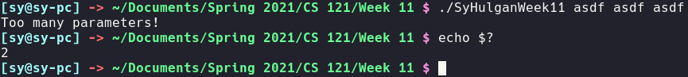

Incorrect input for text file:

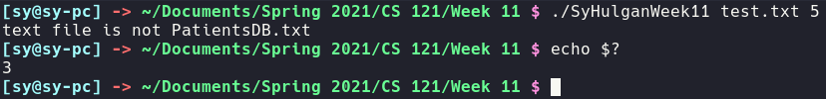

Argument 2 < 1:

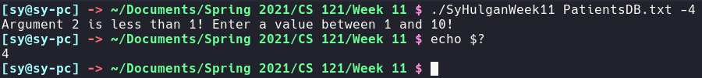

Argument 2 > 10:

